Newsletter

April 2020

DRISA in short
DRISA plans to present, on the internet, a searchable catalogue of the Transnet Image collection, with a thumbnail of each image, freely accessible to railway and history researchers all over the world.
DRISA provides raw thumbnails with brief descriptions. Images are not cropped or enhanced, with no attempt to remove duplicates. Should images be required for illustration or publication, the high-resolution versions are available from the Transnet Heritage Library (THL). Users can digitally restore and enhance the images to suit their own purposes.

Since the previous newsletter…
Our previous newsletter was sent in December 2019, just before the summer break. Owing to the devastating lockdown, DRISA suffered some setbacks in some respects, but continued to record some progress in others:
- The two assistants working for DRISA in the Transnet Heritage Library went on leave at the end of November for two months. During the break, one found a permanent job elsewhere and the other returned at the beginning of February. Since the lockdown, the THL is closed and the DRISA fieldwork by the assistant, the weekly group of volunteers and Yolanda is on hold. A number of work-from-home activities could be continued.
- The R Collection holds 1500 photographs relating to the Royal Tour of 1947. It was the first collection to be digitised by the DRISA assistants and catalogued by Olwyn Garratt. At that time, there were no DRISA “rules” yet and they were developed as we went along. After the R Collection, seven further collections and 20 000 photographs later, the “rules” were developed further and refined as we learned more. During the past month, the R Collection was revisited and updated to be consistent with the rest of the collections. More about the Royal Tour of 1947 later in the newsletter.
- DRISA follows a philosophy of working from the oldest material onwards. As a result, almost all the images on the internet are black-and-white. The THL, however, also holds two large collections of about 20 000 colour 35mm slides (the CS Collection) and the same number of colour negatives (the CN Collection).
- The CN Collection consists of three different smaller collections of colour negatives, each with their own numbering systems. Before DRISA’s time, the three smaller collections were mixed up and rearranged by topics. To untangle the CN Collection, the Monday volunteers first worked through the roughly 800 boxes of negatives and recorded the topic(s) covered by each, as well as recording the numbers of the negatives in each box. One of the assistants started to type up numerous scraps of partial lists and boxes of old, unsorted catalogue cards that were found throughout the THL. In the past two months, all this information was digitally integrated and a single CN catalogue was produced to link the number, topic and library location of each negative. The first 350 colour images from the CN Collection was uploaded to the internet during April 2020.
- We also made a start of the CS Collection. There was no earlier attempt to establish a single collection of 35mm slides – there were numerous small pockets of slides throughout the THL, the vast majority of slides without individual numbers. More than a year ago, the Monday volunteers scoured the THL to bring all the slides together from slide boxes, slide carousels, loose piles and plastic file pockets. Every slide was viewed on a light table and placed in one of 20 broad topics. The slides were then placed in numbered plastic file pockets in numbered files – both pockets and files donated by a kind stationery supplier. Further work on the CS Collection can only proceed once DRISA finds the resources to start scanning the slides – see a request later in this newsletter.
- The descriptions of images on the DRISA platform are constantly being improved and corrected. Many thanks to those (too many to mention) who send regular emails to point out mistakes, or to suggest improvements or corrections.

Use of the photographs on the DRISA platform
All the original photographs on the DRISA internet platform at www.drisa.co.za reside in the Transnet Heritage Library. The DRISA platform is planned as a finding aid where the general public can browse the collection without costs or registration to find lo-resolution images that may be of interest or use to them. Better resolution images can be requested from Yolanda Mayer, the librarian at the THL, subject to the conditions that Transnet may impose on their use.

It is very pleasing to observe that there is an increasing use of the THL images to illustrate books and articles that record South Africa’s fascinating railway history – exactly the motivation for starting the DRISA project a few years ago. Most readers will be familiar with SOUL OF A RAILWAY, that unique website that is piecing together a very detailed pictorial history of the South African railway network, one section after the other. Charlie Lewis and Les Pivnic are using the finest of the photographs of taken by our most eminent railway photographers, including some of the THL images.

Two recent articles serve as further fine examples of the power of visual images, both appearing in Bulletin 132 of the Western Cape Railway History Group, edited by Geoffrey de Vartek. With his permission, the bulletin is sent out together with this newsletter. The papers by Leith Paxton and Allen Duff utilise images which were only “discovered” after appearing on the DRISA platform. Well done guys!

Working from home…
“Working from home” may be one of the positive spin-offs of our current misery. We therefore ask one or two of the supporters of the DRISA project to consider investing in their own dedicated slide scanner. It would help DRISA so much if you could scan some of the THL colour slides in you spare time from the comfort of your home office. Most of us are older, with loads of personal slides that need attention anyway! If you have such a scanner, or consider getting one, please contact us to take it further. DRISA follows the THL policy of not allowing any of the older, fragile material to leave their premises, but DRISA is confident that an arrangement could be made to courier one file of pocketed slides at a time to trusted DRISA contributors. There are many claims about using regular A4 scanners to scan colour slides, but the quality is disappointing unless one goes to the very top end of regular scanners. Dedicated slide scanners are small and compact, specifically targeted to process colour slides and they go at less than R10k.
Please give it a thought!

Contact details

For questions and comments, please contact Johannes Haarhoff at johannes@haarhoff.org.za, Yolanda Meyer at Yolanda.meyer@transnet.net or visit www.drisa.co.za .

Help with these railway stations and locations!
In reworking the R Collection about the Royal Tour of 1947, we could find many of the unknown locations with the help of official programmes and annotated photo albums. There are about 5% of the images where proper description still eludes us – below we show 14 images. If you can help, please send the number and the location of the image to the address above. These are no trick questions – we really do not know! Thanks!
---oooOOOooo---

This photograph is from a location in Bulawayo. Could it be South Park? (R1015)

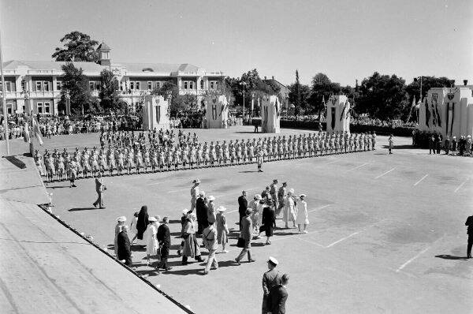
Here three railway stations. Locations? (top R0476, middle R0668, bottom R0478)

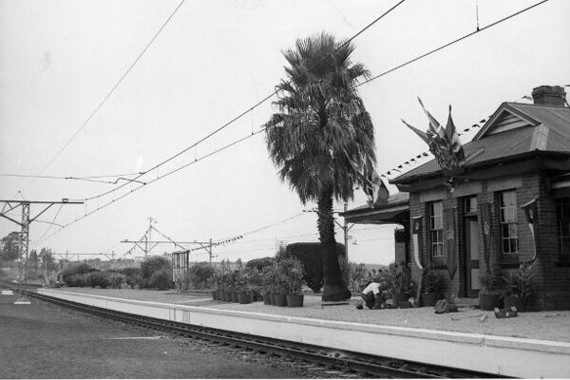

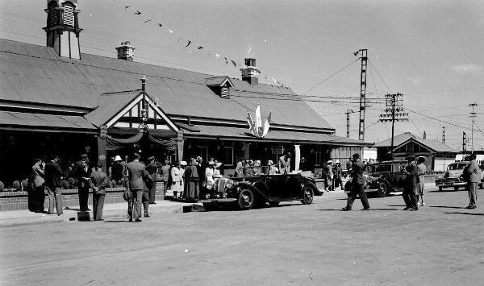

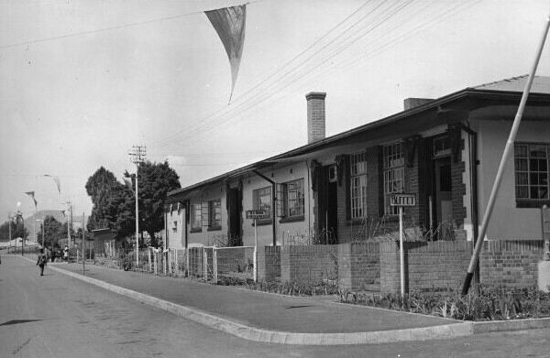

These two lines are in Natal. Where? (R1281 top, R1299)
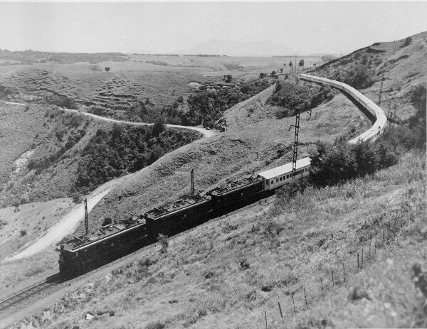
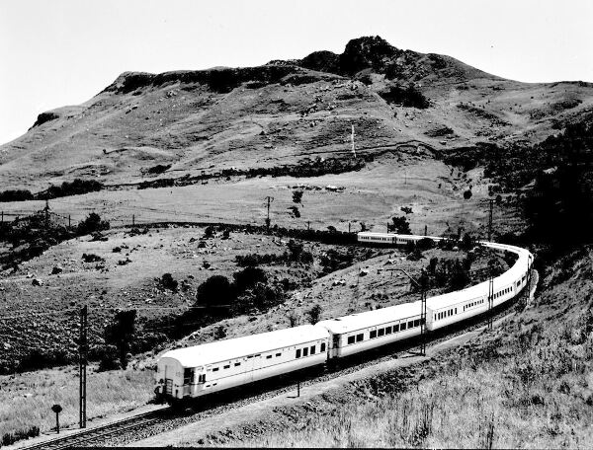

This is near Victoria Falls, something to do with Spencer Airways. What is on the trailer? (R1341_3)
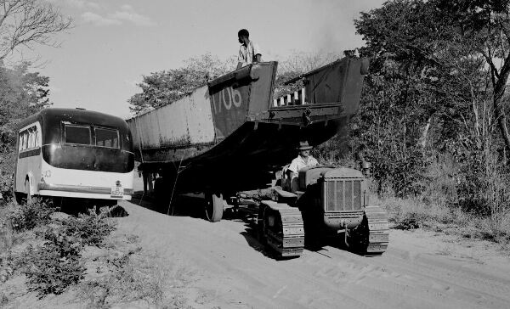
Three street scenes. Where? (Top R0494, middle R1229, bottom R1293)

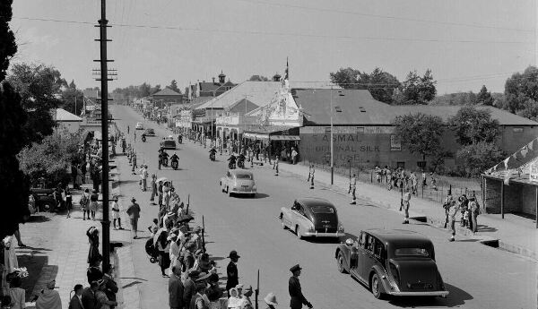

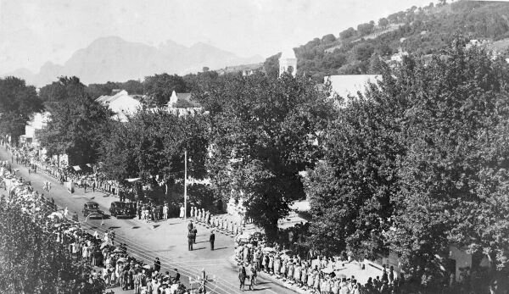

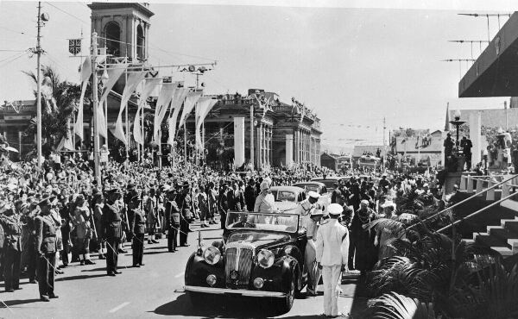

Three unknown towns. (R0492, R1291, R1366)

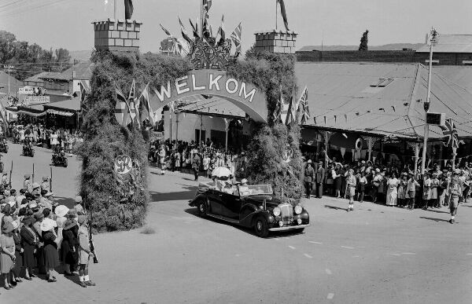

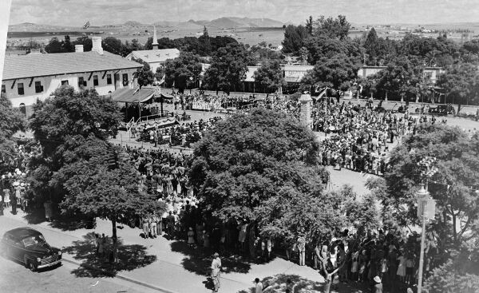

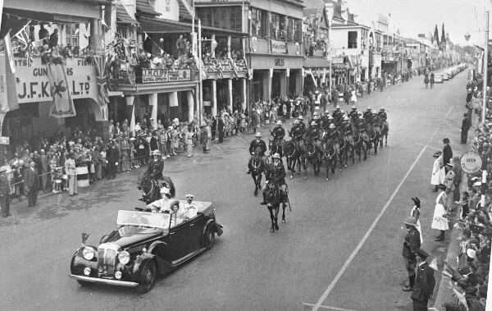

We suspect this could be in Durban. Confirmation? (R1309)

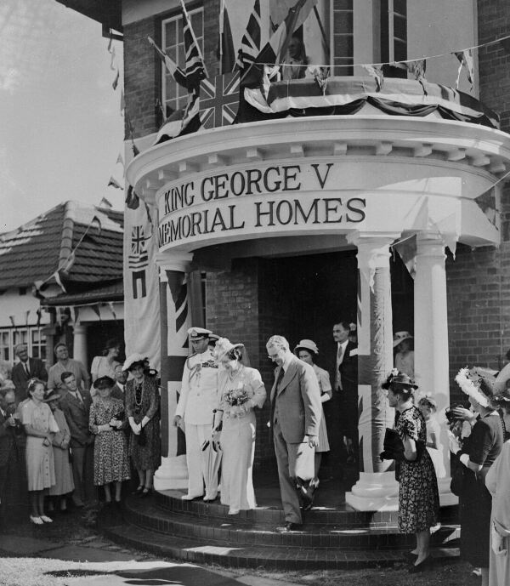

---oooOOOooo---

